Heart of Ballet Project 4
Working with two principal dancers
during a practice session
– the power of focused attention

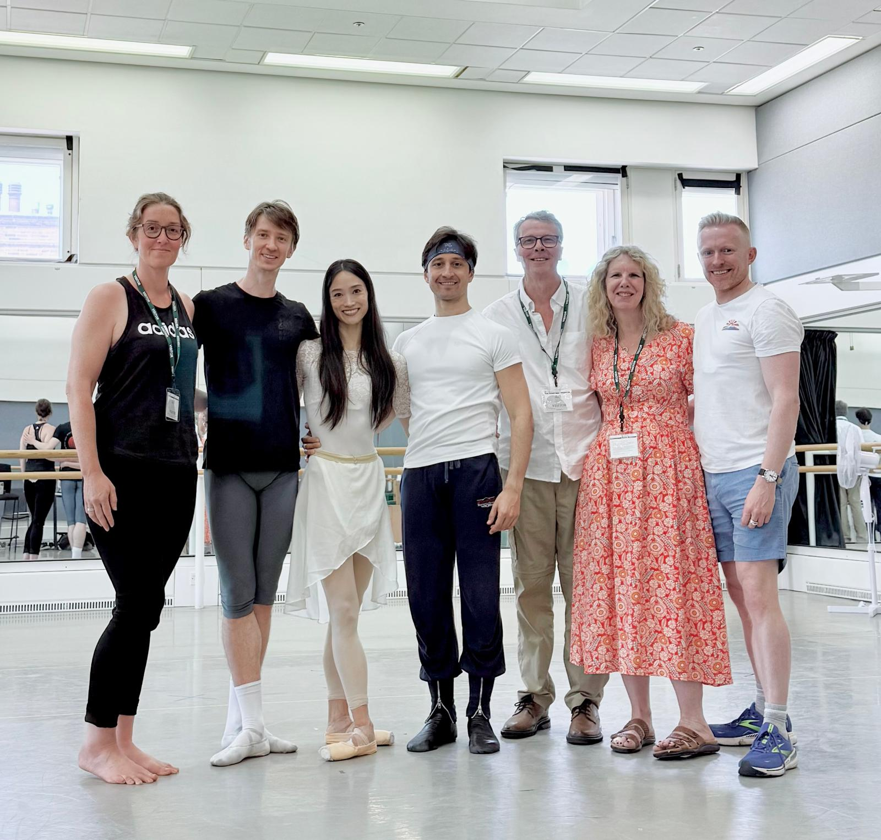
The dancers and research team. From left: Rosie Collins, Vadim Muntagirov, Fumi Kaneko, Valentino Zucchetti, Peter Granger, Claire Berry and Tim Duncan (photo courtesy Tim Duncan)

In August 2024 Heartbond and Collision Unknown started working on our exciting Heart of Ballet project. Since that time, we have been able to investigate the powerful way that heart rate synchronisation connects dancers and audiences through Heart of Ballet 2 and 3 and you can read about our early projects here https://www.heartbond.co.uk.
Through our work we could see a common pattern emerging. When dancers focused on each other or on the choreographer, there would be a strong synchronisation of heart rate variability (HRV). This excited us and made us want to find out more.
In the fourth instalment of the Heart of Ballet experimental series in July 2025, we had the opportunity to work with two principal dancers from the Royal Ballet, Fumi Kaneko and Vadim Muntigarov. This session became Heart of Ballet 4, and it focused on HRV synchronisation during the rehearsal of a pas de deux. The choreography was created by Valentino Zucchetti and the piece, still in development, was set to be performed two months after our visit. The generosity of Fumi, Vadim and Valentino enabled us to have an authentic insight into the creative process which built on the rehearsals that we had seen in Heart of Ballet 2.
What questions were we going to investigate?
This experiment was set up to answer the following questions:
- Would we see strong synchronisation between the dancers and the choreographer during a practice session?

- We were particularly interested to see if the focused attention of an audience member on a dancer would lead to them synchronising their heart rate patterns with them – something we had seen before in the earlier projects and our existing research.
For this experiment both dancers, the choreographer and the audience wore heart rate monitors. We were able to capture the dancers’ HRV during periods of dance and rest, when they were watching demonstrations from Val and deciding on moves for this new piece. We also measured the heart rate variability of a small audience, who knew each other. They were seated together during the practice and were free to talk quietly.
The heart rate data collected by the heart rate monitors was shared with the console that displayed the synchronisations in real time. The dancers, choreographer and half of the audience did not watch the real-time results; however they were viewed by the two members of Heartbond, Peter Granger and Claire Berry, who were able to watch the synchronisations unfold as it happened. After the practice the data was processed and displayed to allow more detailed interpretation.

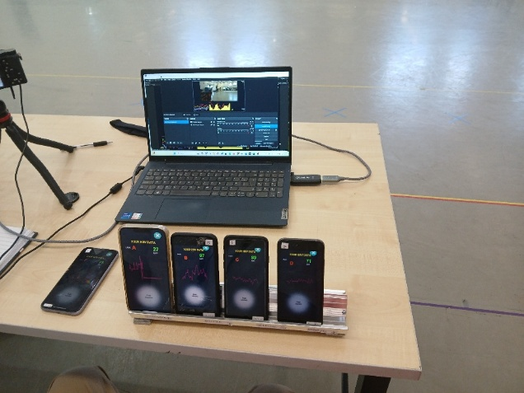

So, what did we found out?
Returning to the questions that we had brought to this experiment, we were curious to follow the synchronisation between the dancers and the choreographer. Notably, when the dancers and choreographer focused together on solving a challenging movement - all three exhibited high physiological synchrony and exhibited a shared rhythm that was not always mirrored by the small audience of four observers. We felt that this could reflect the importance of focus or attention. In our earlier work we could see that when we focused intently on someone we were more likely to synchronise with them. Was this what we were seeing here? This led us naturally to the second research question.
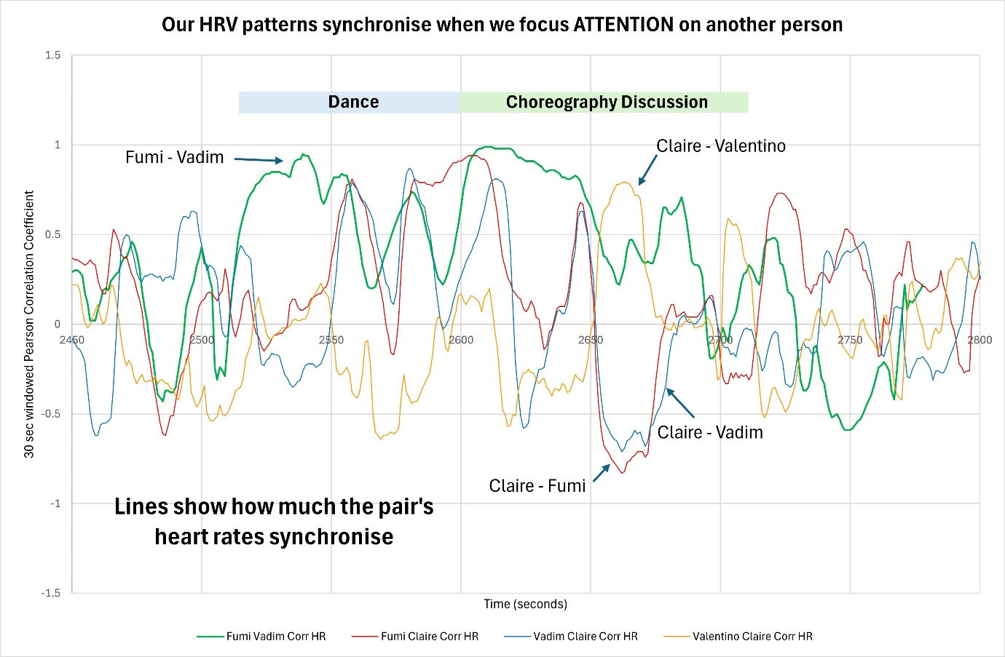

The graph above shows an example of data from this project. It focuses on Claire; an audience member as she changed her focus between the dancers and the choreographer. Each line on the graph shows the amount of synchronisation between Claire, the two dancers (Fumi and Vadim) and the choreographer (Valentino). From this we can see that Fumi and Vadim were highly synchronised during the dance sequence. Claire's heart synchronisation moves from Fumi and Vadim to Valentino as her focus changes from the dancers to Valentino, as he discussed and demonstrated the choreography.
We have seen the importance of attention to HRV synchronisation throughout our research. We believe that this is very significant to our understanding of audience engagement in the performing arts and to the broader understanding of relationship dynamics.
We also found that the greatest levels of HRV synchronisation were observed during extended sequences of continuous movement and, when individual movements were isolated for perfection, synchrony between the dancers noticeably decreased. This suggests that flow and mutual awareness are crucial to deep connection in partnered dance. Perhaps we find it easier to synchronise during complete performances?
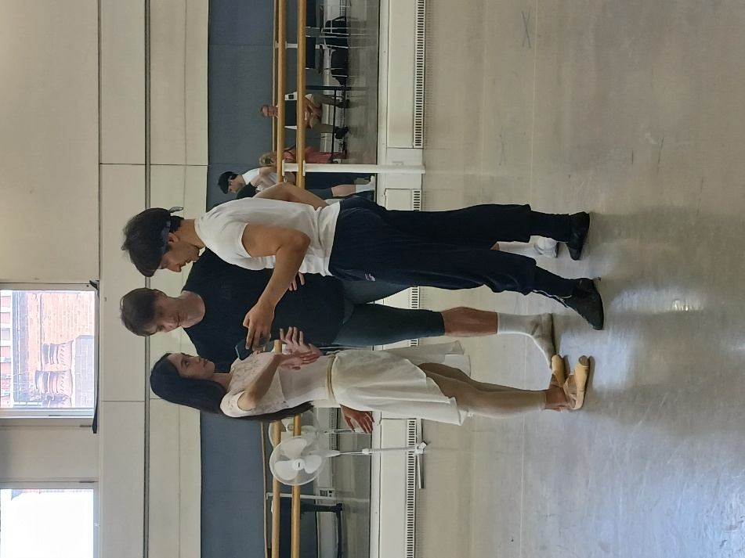

Audience behaviour also played a significant role in the synchronisation observed. When individuals talked to each other or shared their excitement verbally, their synchrony with the dancers diminished while their synchrony with each other increased. This highlights the importance of focused, undivided attention in establishing a meaningful connection with live performance.

What are we going to do next?
Building on these promising insights, the next phase of the project will need to measure synchrony during the performance of a fully rehearsed piece. We could see the power of focused attention on synchrony and the findings of Heart of Ballet 4 have shown us that this is easier for the audience when the dancers perform a completed piece.
Given the synchronisation that we saw as Claire viewed the two dancers and then the choreographer, we wonder if this could happen the other way round – performers might pick up audience members heart rate patterns, especially if the audience is synchronising en masse. We are planning to investigate this fascinating possibility in the future.
We are also interested to investigate whether other forms of performance would show the same results. Would a music concert show the same results as the ballet? This is an area that we have already started investigating.
Our work has allowed us to assess how rehearsal, physical exertion, muscle memory, emotional connection and artistic confidence have influenced HRV synchronisation, not only between dancers, but also with the audience. Heart of Ballet 4 continues to underline the remarkable interplay between focus, collaboration, and shared experience in the world of professional ballet.
Our thanks go to Fumi Kaneko, Vadim Muntigarov, Val Zucchetti, Rose Collins and Tim Duncan. Without their generosity, this work would not have been possible.

