Heart of Ballet - Project 3
Displaying our heart synchronisation
to audience in real time
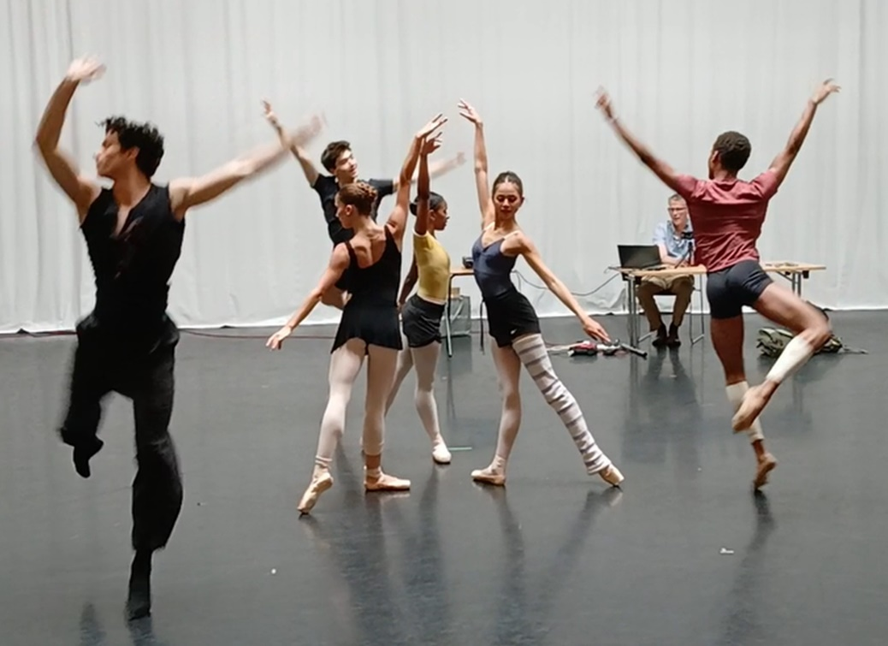

The background to our work
In August 2024 Heartbond and Collision Unknown worked to create our first Heart of Ballet project. When we looked at the results, we could watch the heart rate patterns synchronise between the two dancers, the audience and between the dancers and the audience. We followed Heart of Ballet 1 with Heart of Ballet 2 where we worked with dancers and their choreographer during the creative process. This research showed us the high level of synchronisation between dancers and their choreographer and audience members.
You can read the reports in full on ‘Our Projects’ page on our website https://www.heartbond.co.uk/projects
The findings of Heart of Ballet 1 and 2 helped us to create new technology to monitor the synchronisation of heart rate variability in real time. Drawing on our past experiences we decided that our next step was to measure a larger audience group and to show their synchronisations in real time. To do that we decided to display the synchronisations back to the audience whist the dancers performed. We settled on representing the synchronisation by a virtual sun that would change its brightness in response to the strength of the synchronisation.
To create this experience the teams at Heartbond and Collision Unknown went back to the rehearsal room with a group of apprentice dancers from the Royal Ballet. They generously gave their time to perform a short original piece twice, that had been created for them by dancer and choroeographer Valentino Zuccehtti.
What questions were we going to investigate?
For this experiment we were interested to find out:
- Would the heart rate variability (HRV) of the audience members synchronise and if so, when during the dance?
- If we displayed the HRV synchronisation of the audience during the performance, would that enhance the experience and lead to more synchronisation?
The performance was presented to a small, diverse audience that included individuals with limited or extensive experience in ballet which proved particularly valuable in understanding how familiarity of dance affects engagement and synchrony.
The piece was performed twice in uninterrupted form. During the performance Heart rate variability (HRV) synchrony was recorded for a small audience (5 people). In the second performance, an interactive visual display was introduced which fed the HRV synchronisation results back to the dancers and the audience in real-time. This was created through a digital sun display where the image shone more brightly when the synchronisation was at its strongest.

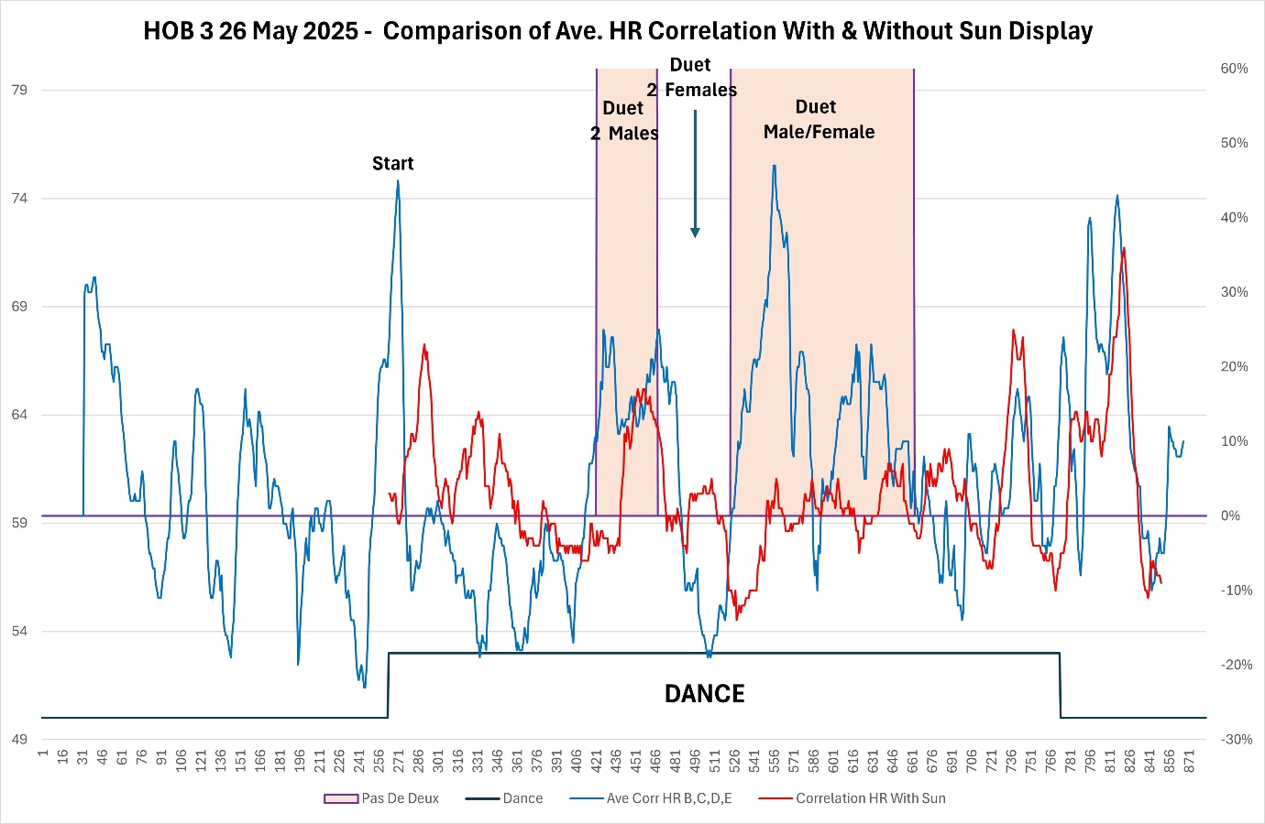
Comparison of audience HRV synchronisation with and without the feedback driving the pulsating sun image.

What did we find out?
If we return to our questions that we asked at the start of our work and ask whether the audience members would synchronise during a new performance, then we found that the audience members with extensive dance knowledge exhibited the highest levels of HRV synchrony with one another. This implies that a more trained or experienced viewer may be better able to attune to the rhythms and emotional contours of a dance performance, thereby enhancing their physiological alignment with others. We had seen this trend in Heart of Ballet 1 and 2 and we conclude that some audience-members could be described as ‘super-connectors’.
During the first performance, without the sun image, the audience members demonstrated the highest HRV synchrony during the pas de deux sequences, particularly when the dancers’ emotional connection was most visible. This finding reinforces the idea that emotionally resonant movement fosters a shared experience among viewers.
Interestingly, some participants indicated that the awareness of being recorded heightened their engagement with the performance, suggesting that the act of observation can itself deepen audience focus.
When we measured the synchronisation when we displayed the heart rate synchronisations to the audience using the pulsating sun image, we saw less synchronisation than with the feedback image. Through the self-report comments that we gathered it became clear to us that, the binary nature of the current “sun” model was found by some of the audience members to be distracting and that that the display detracted from their immersion in the performance. This suggests that future iterations should aim for more nuanced visualisation that supports rather than competes with the choreography. It is clear there is a huge potential for exploring the psychological impact of delivering real-time HRV synchronisation data to an audience – something we are actively engaged on with our academic partners.

What are we going to do next?
The Heart of Ballet 3 has provided valuable insights into the interplay between emotional choreography, audience experience, and physiological synchrony. The contributions of the apprentice dancers with the choreography of Val Zucchetti created a powerful foundation for exploring shared emotional response. With continued development of our visual tools and expansion into varied genres, we are well-positioned to further uncover how dance creates collective emotional and physiological experiences.

